**ROUTE 53**

**Step 1 login into aws console -->click services-->open network-->select route 53**

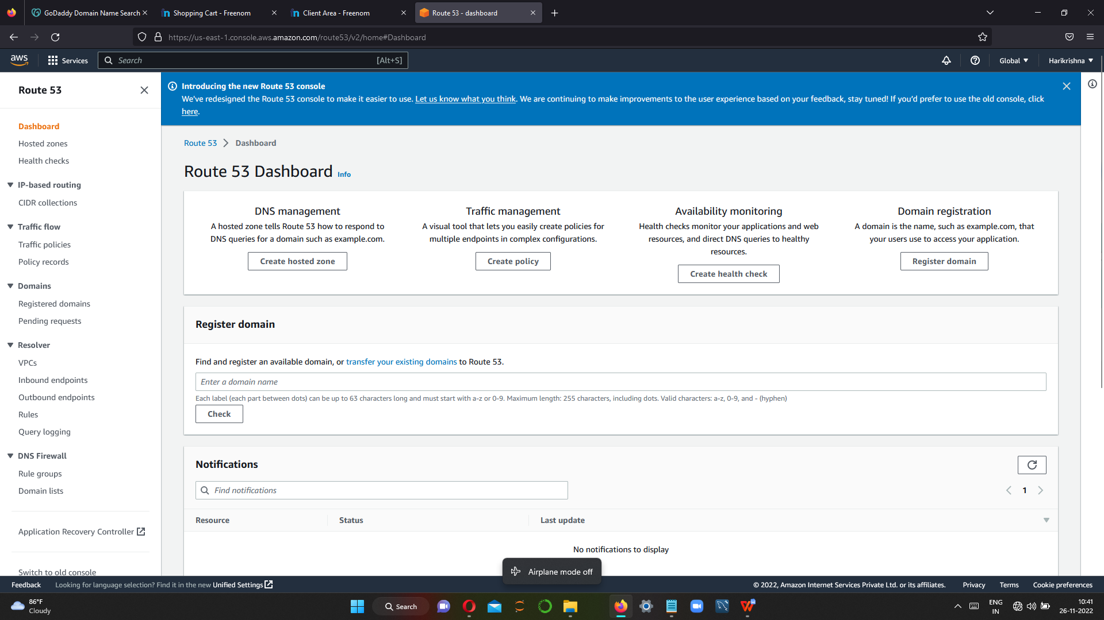

**Step2 create host zone for that we have buy domain names from godaddy,freenom…etc**

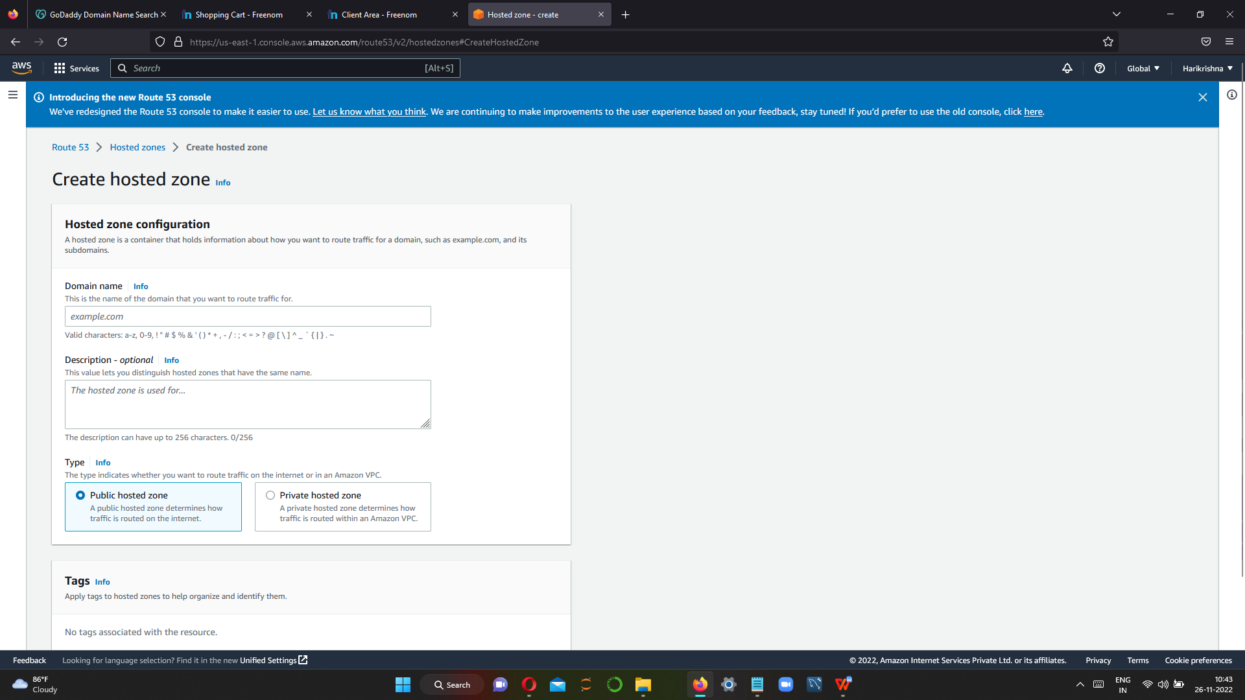

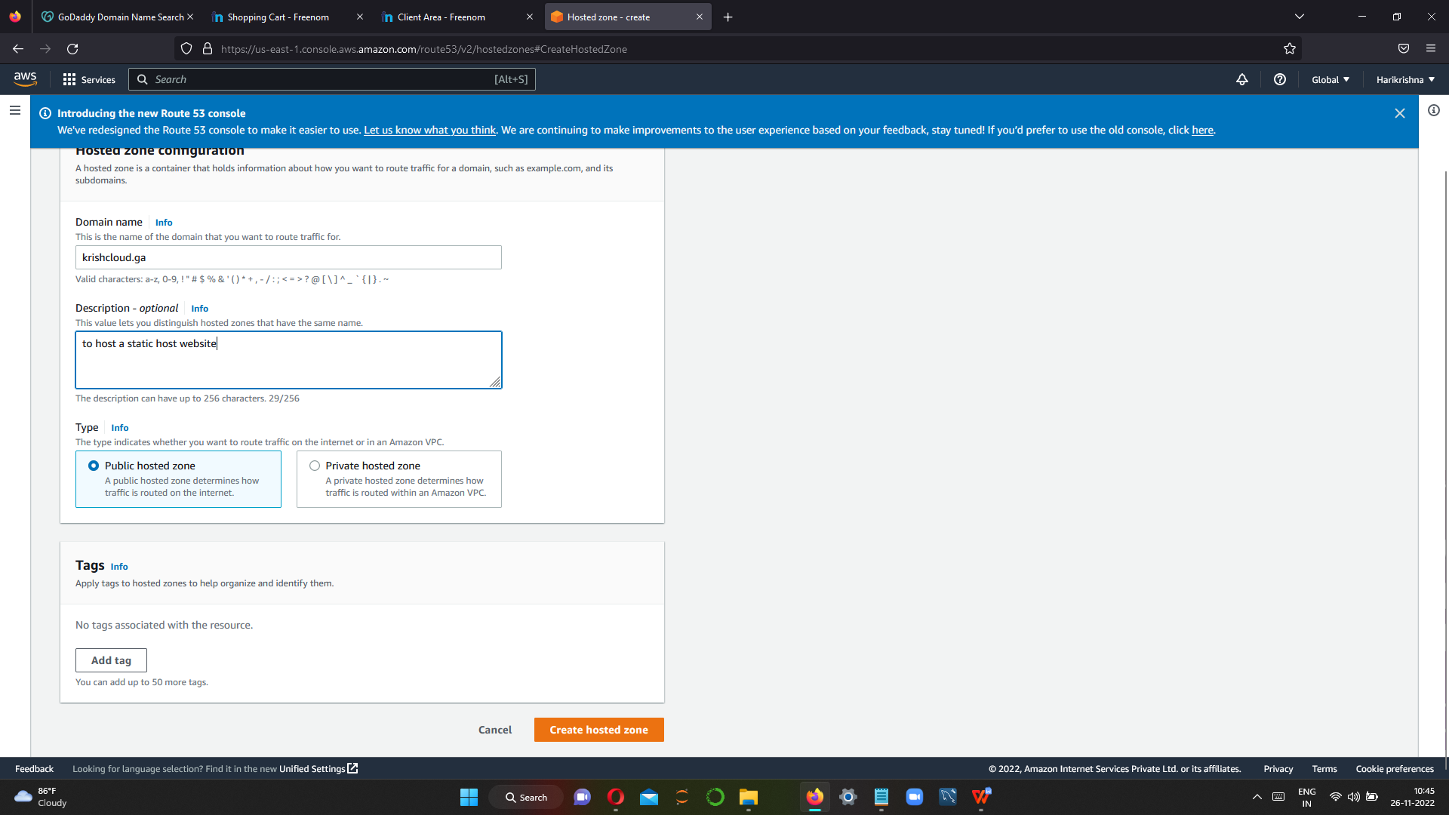

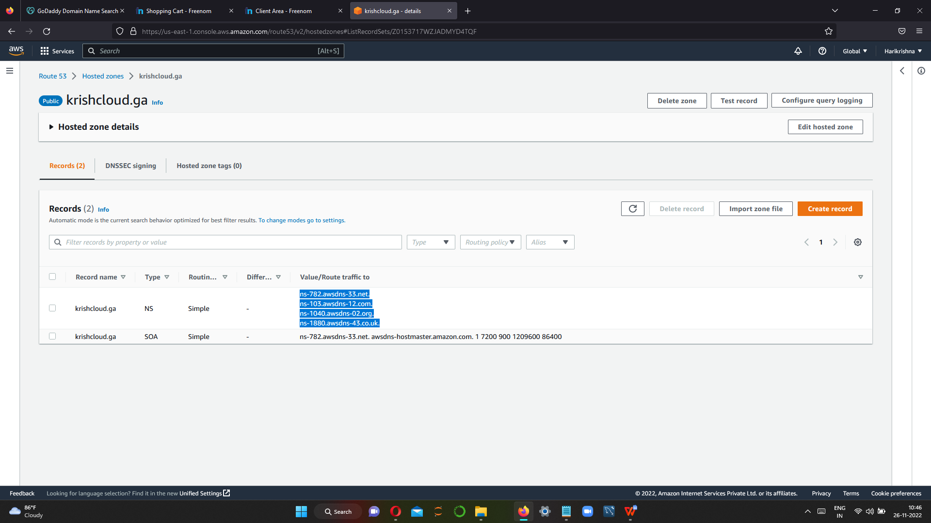

**Copy the name servers and paste to the domain name registarar details**

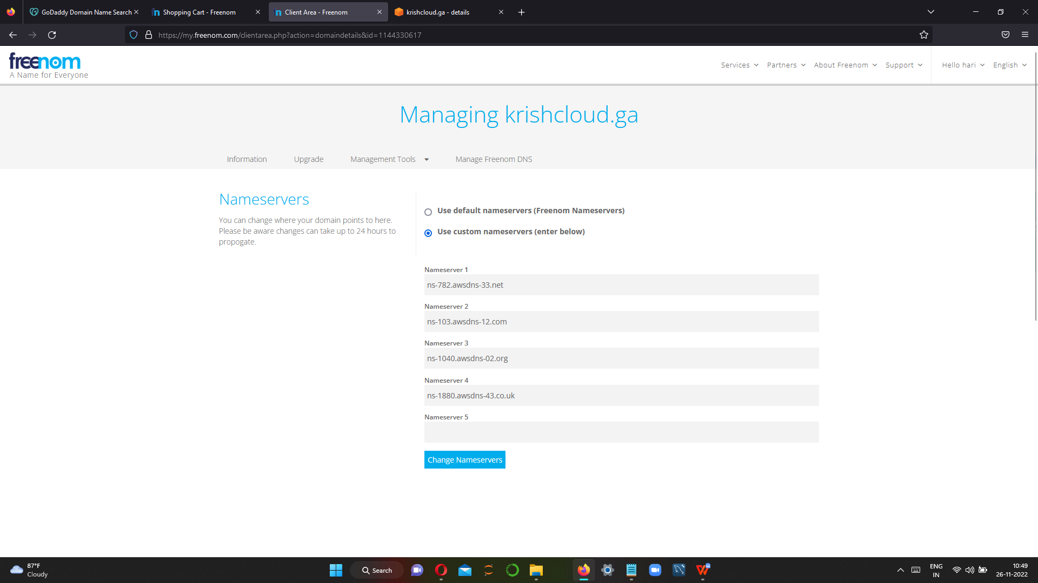

**Step 3 create routing policy**

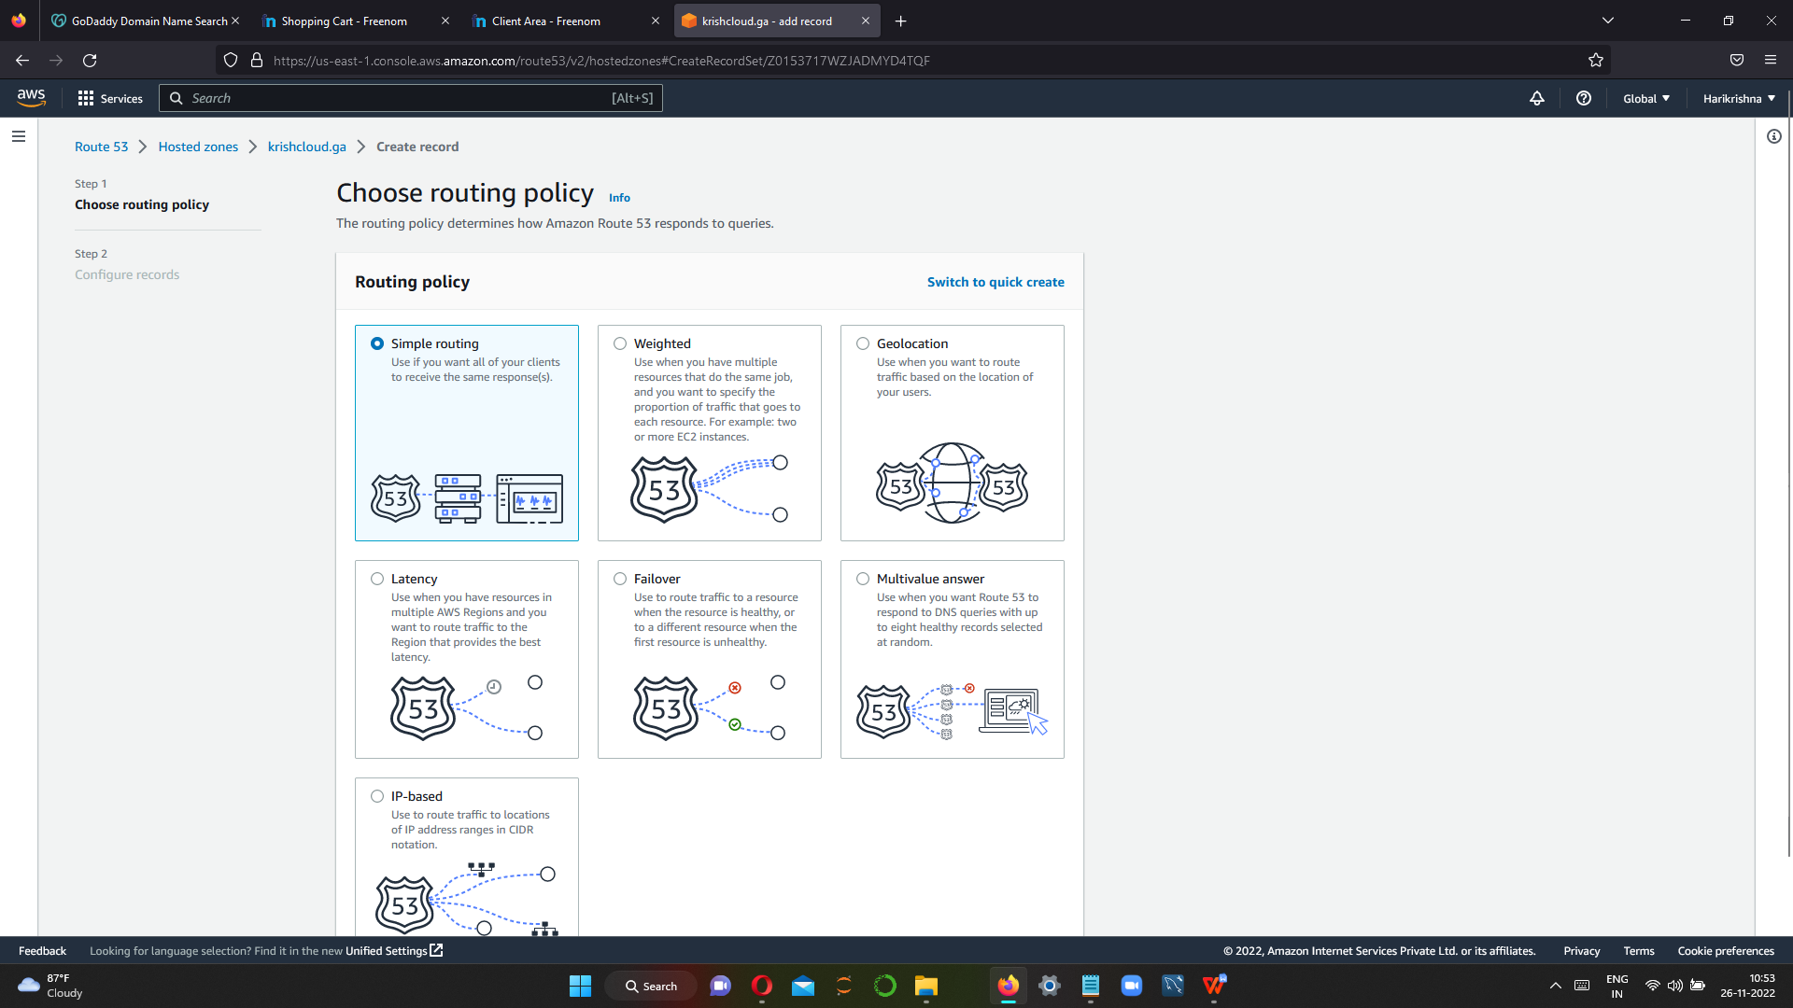

**Step 4 for creating routing policy ,we have to create instance first**

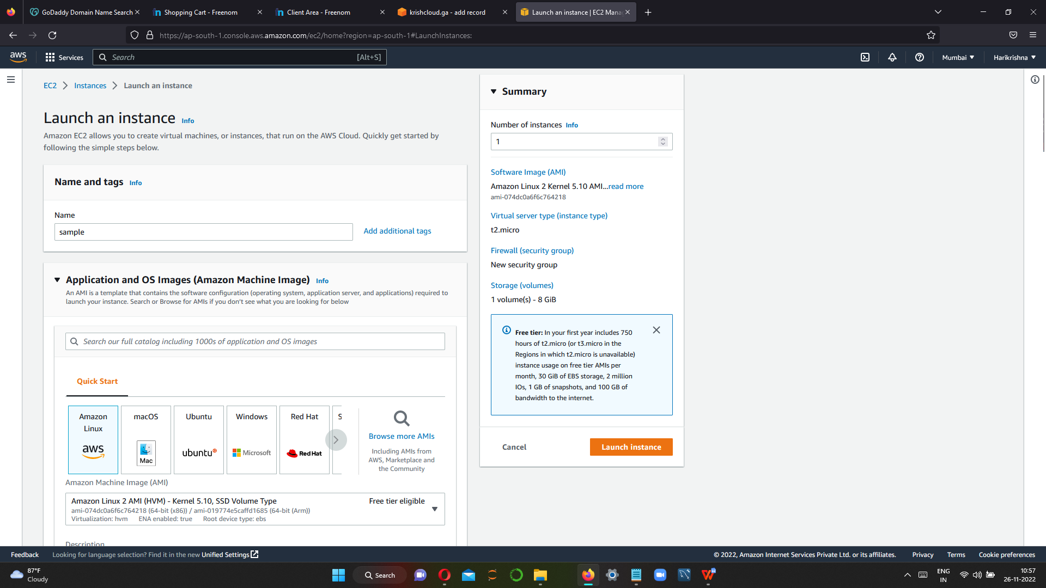

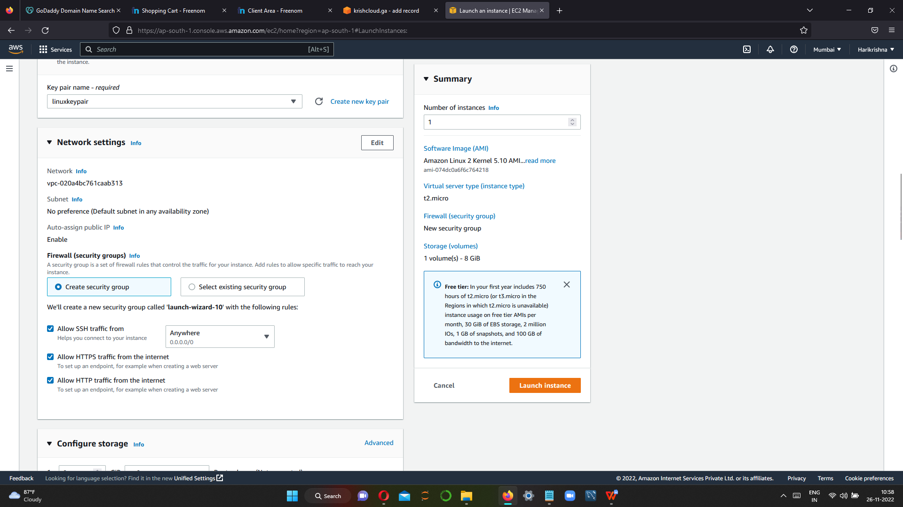

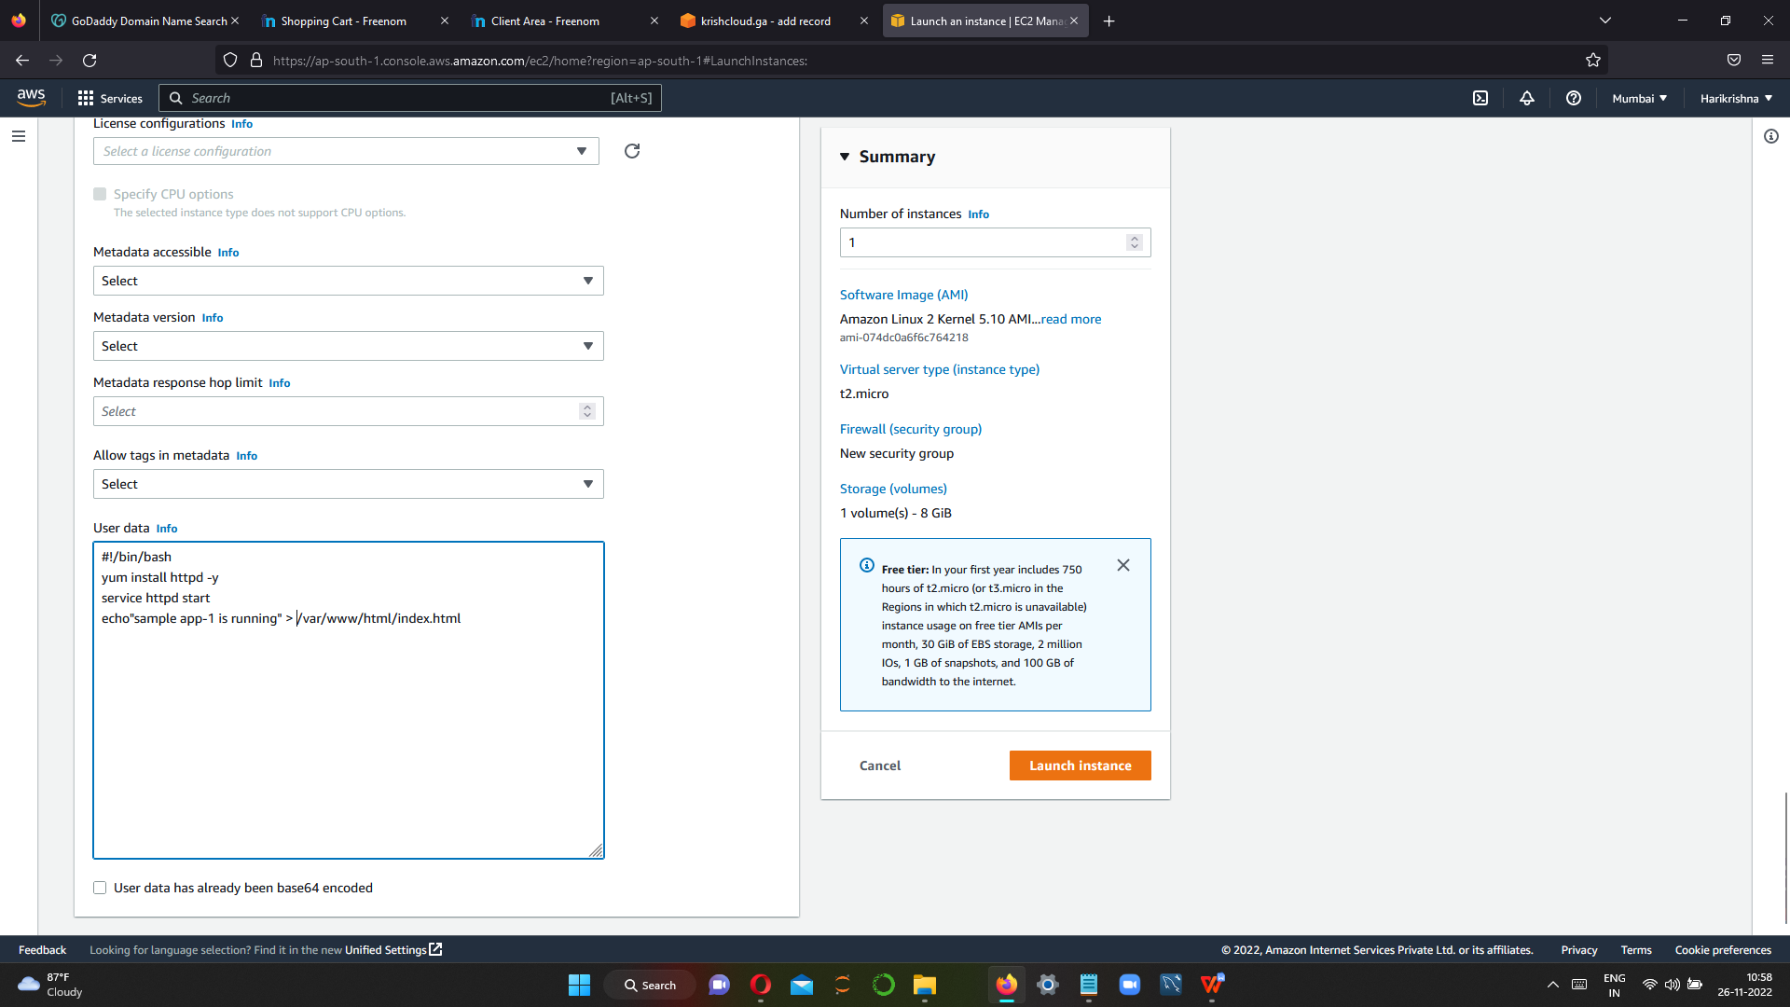

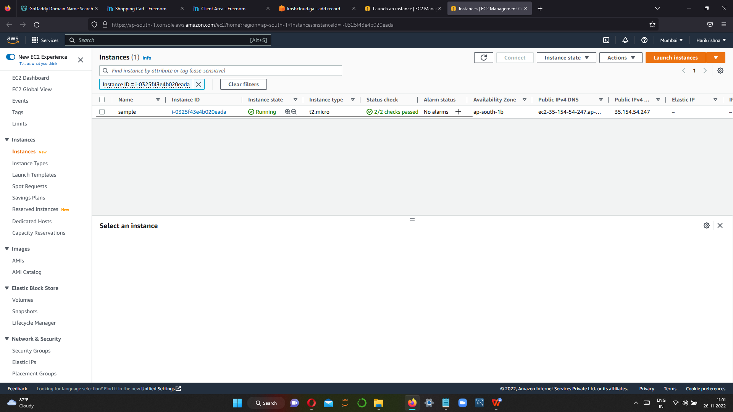

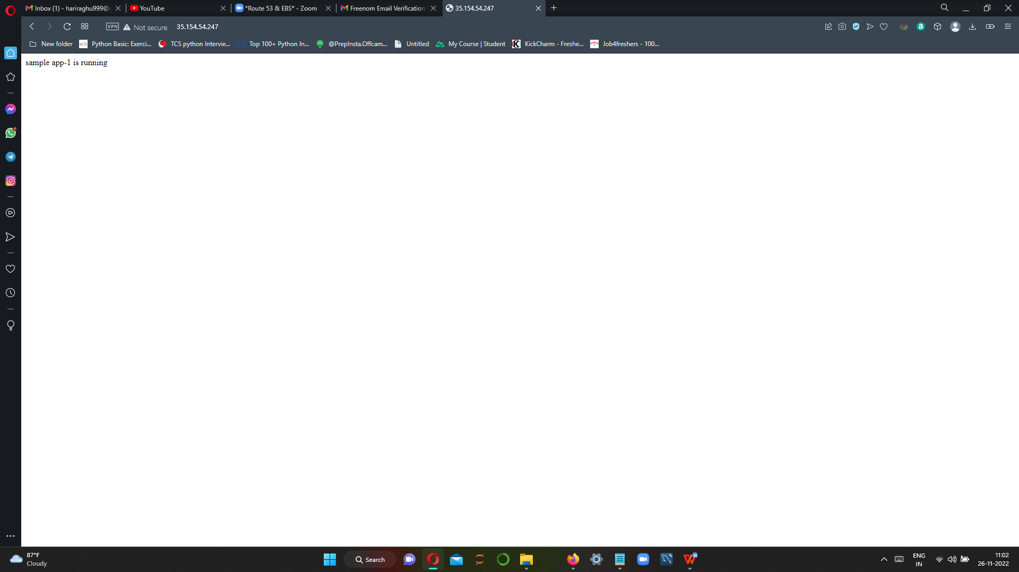

**Step 4 we have create A record for routing policy using public ip address of created instance.**

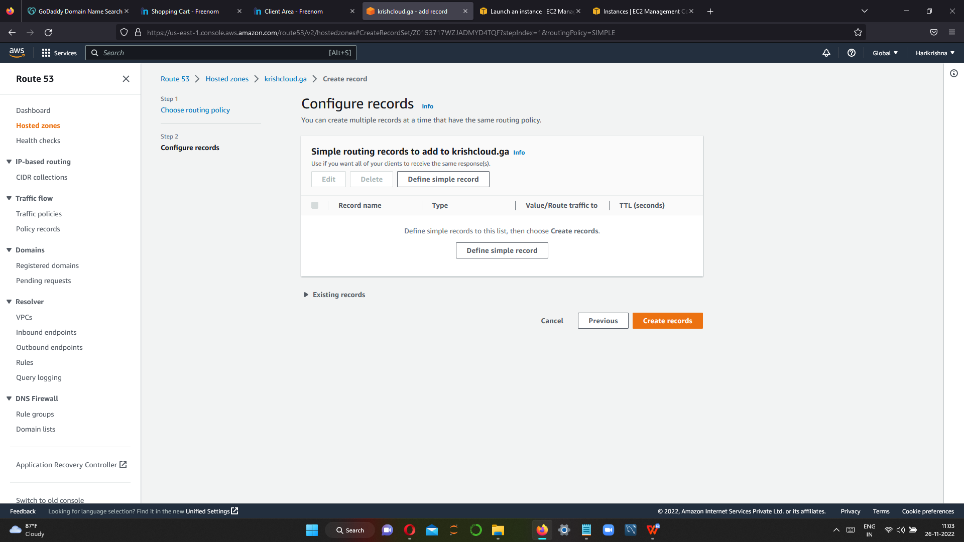

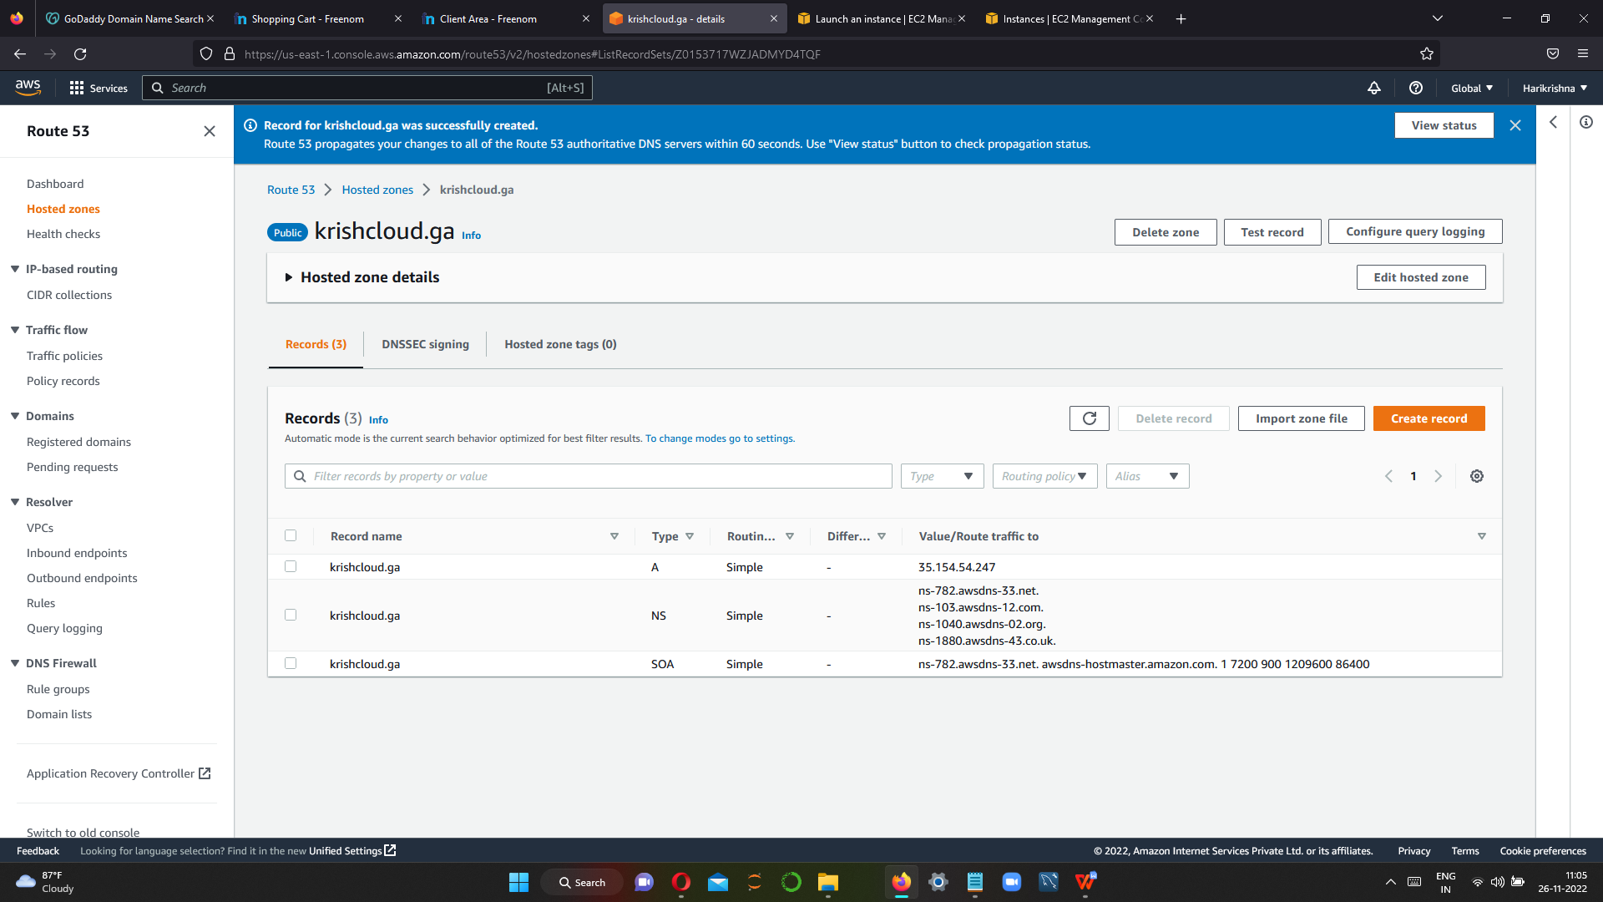

**A record is created ,now we have to hit the domain name in browser to see it running or not.**

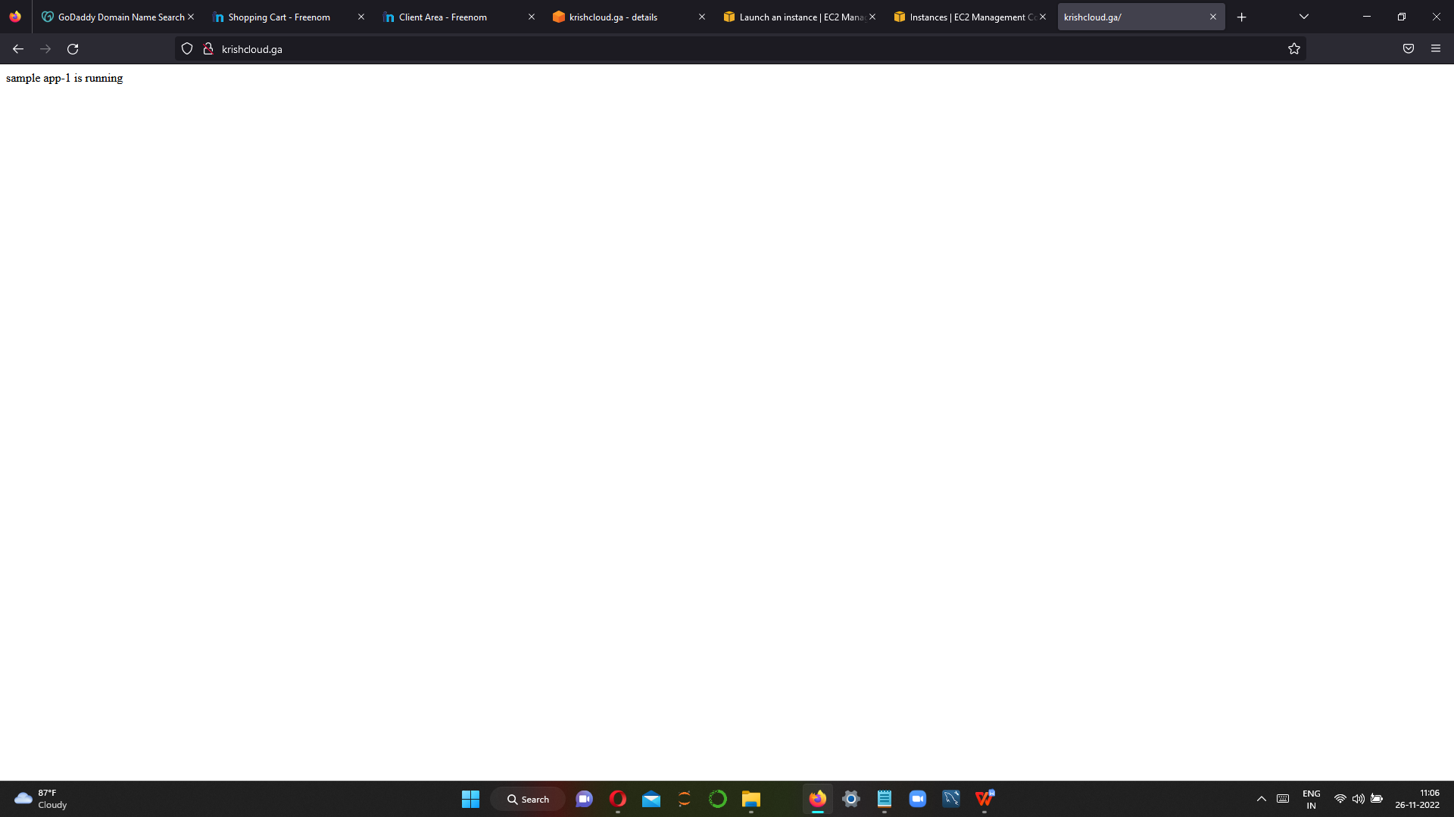

**This is simple routing policy**

**Step 5 Geolocation routing policy..**

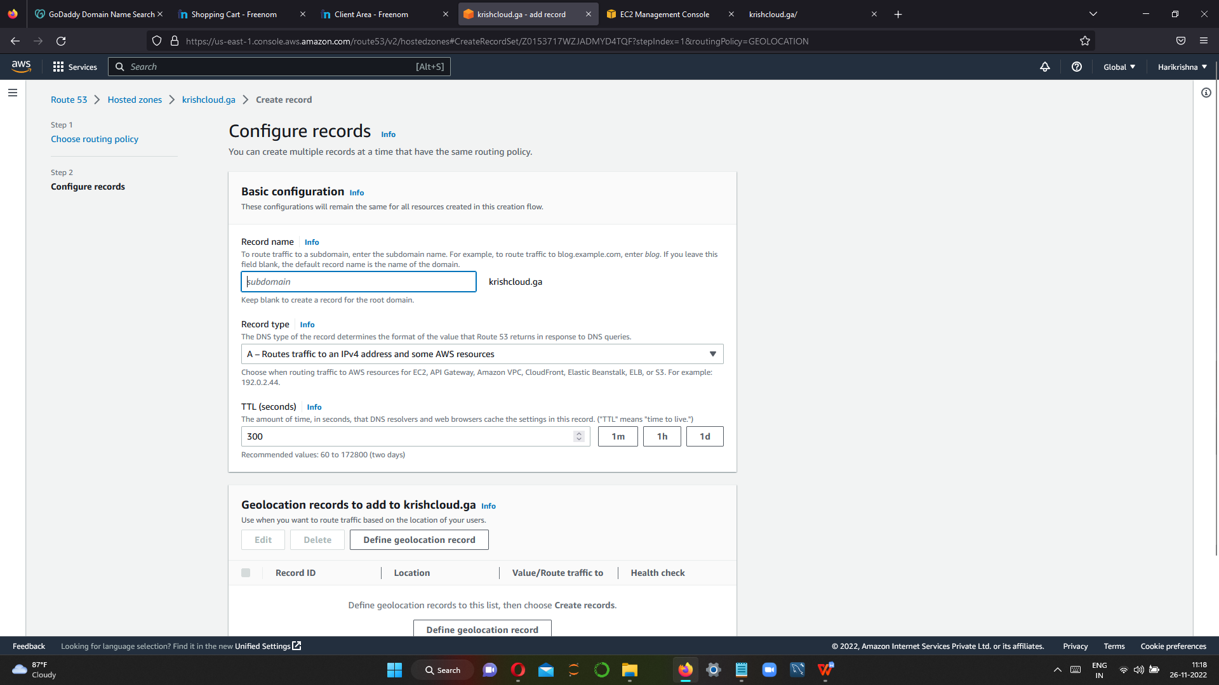

**Now we have 3 instance and we can give 3 different location for 3 instance.**

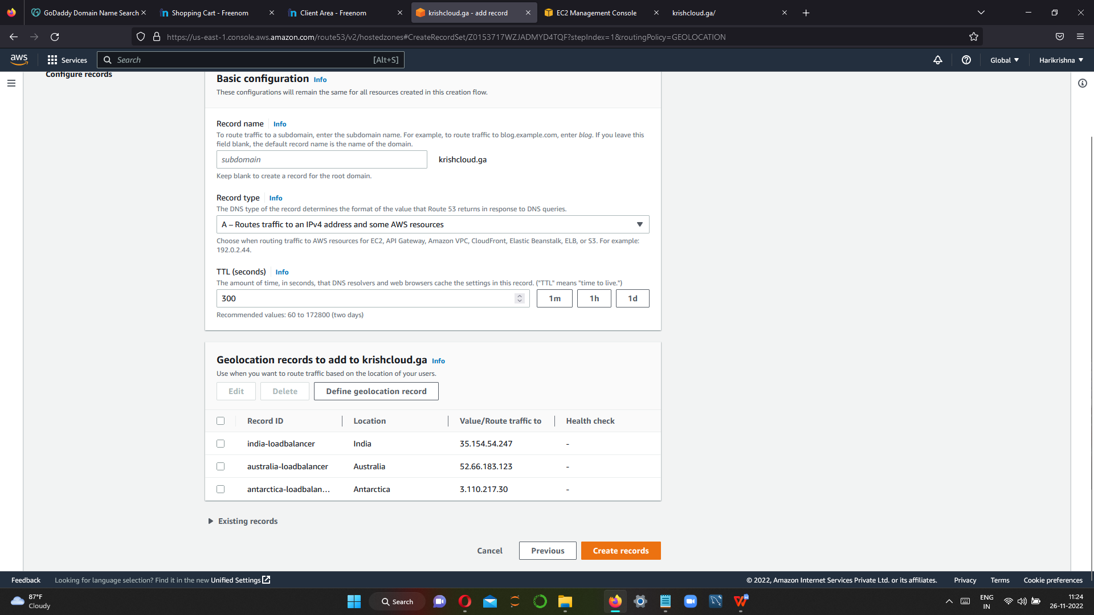

**We have given 3 different location for 3 instance ,sample instance -->india,sample 2 instance-->europe ,sample 3 instance--> america**

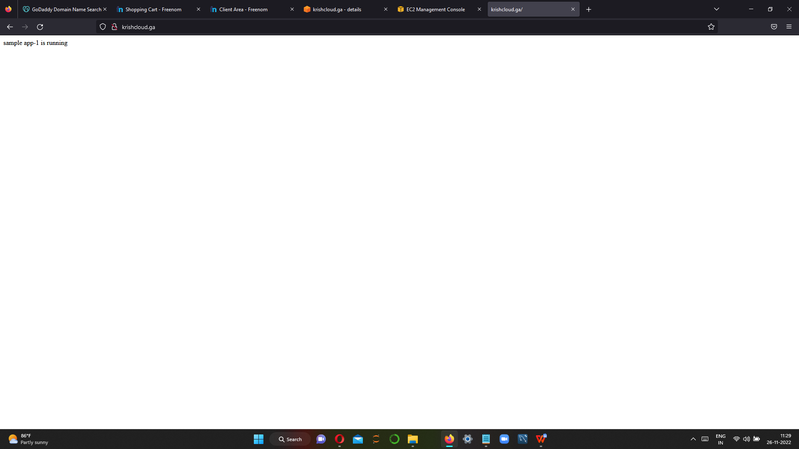

**Sample app1 is running it connected to location india**

**Step 6 we have to delete sample1 instance and run sample 2 and sample 3**

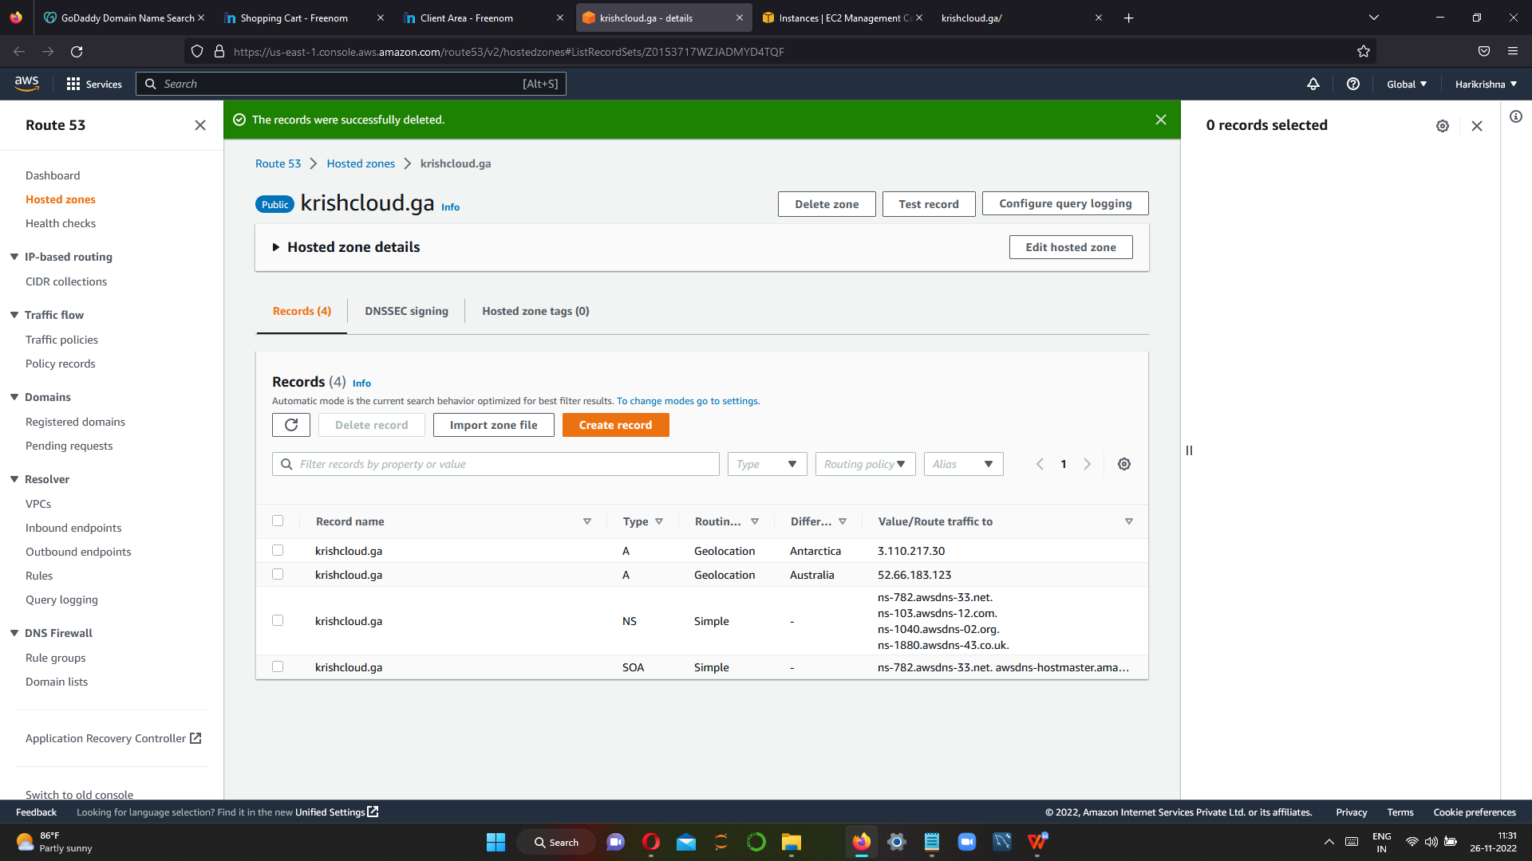

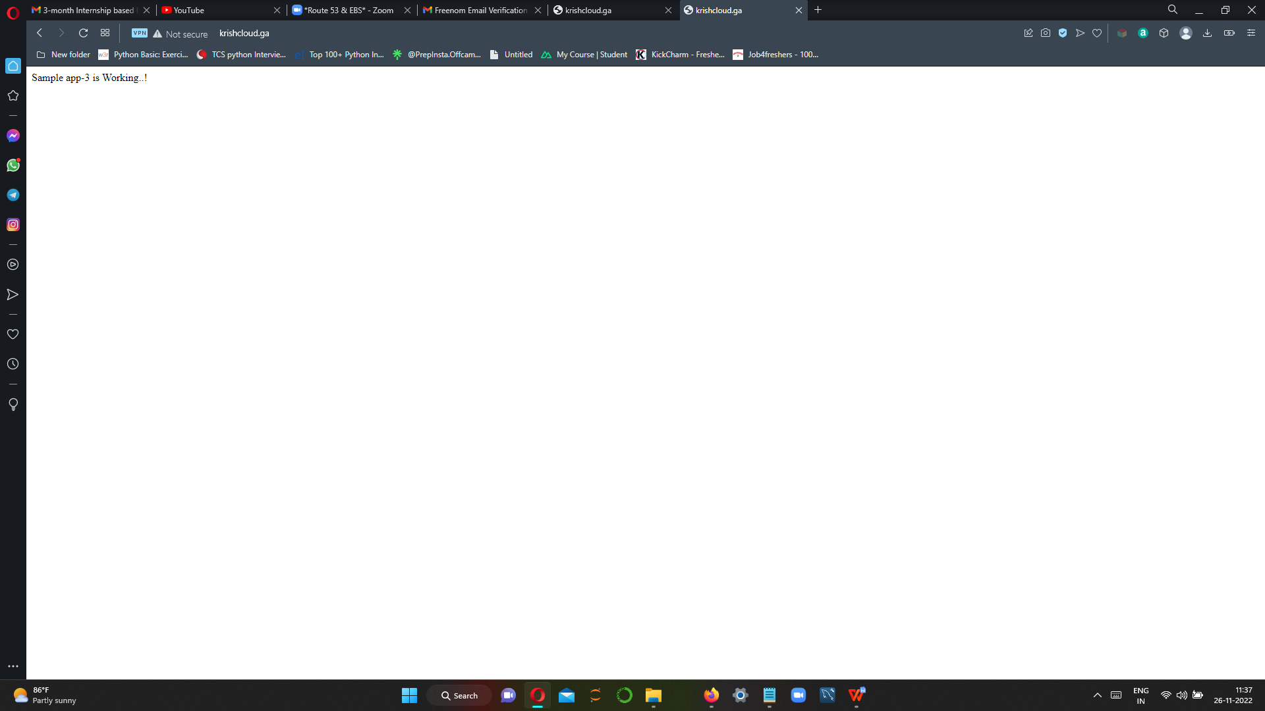

**Now vpn is in america so sample 3 instance is running, we can connect vpn to sample 2 instance for checking**

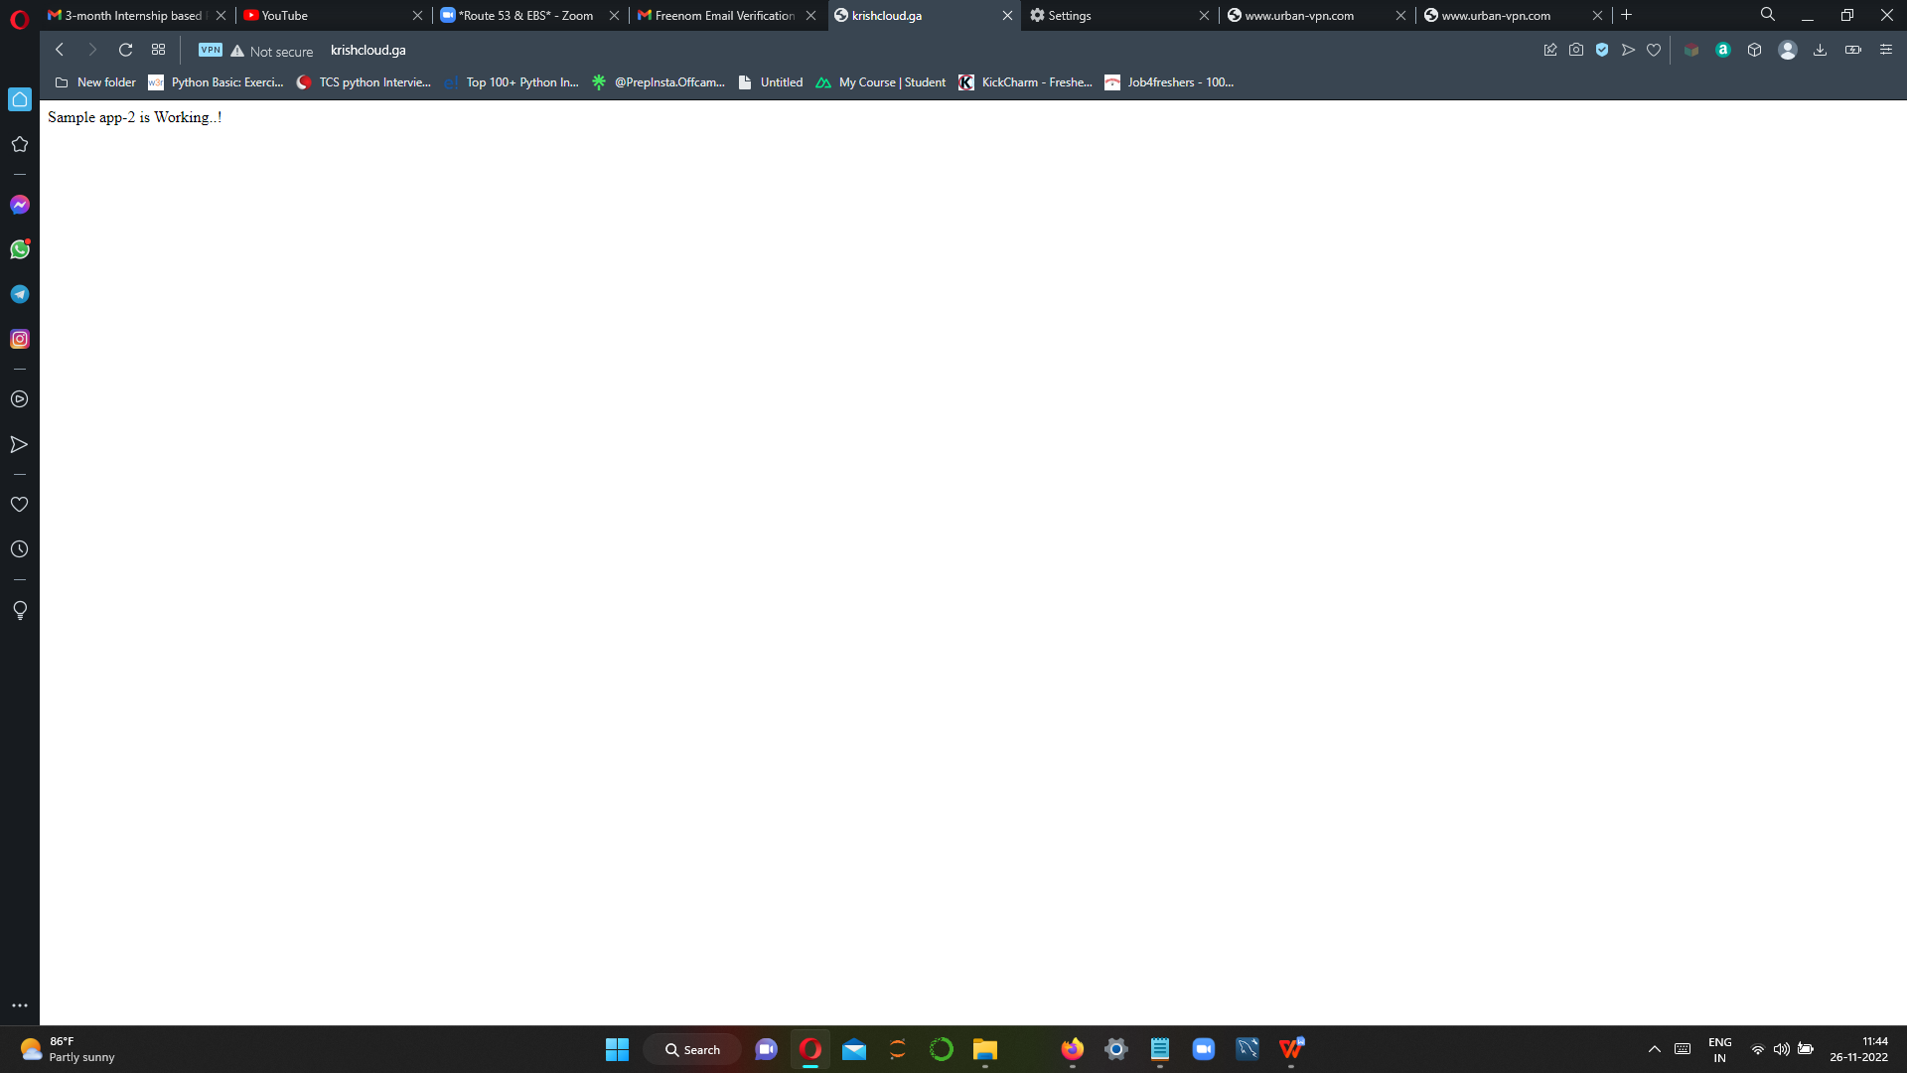

**Sample 2 instance geolocation is europe ,we connect vpn to europe and sample app 2 is running**